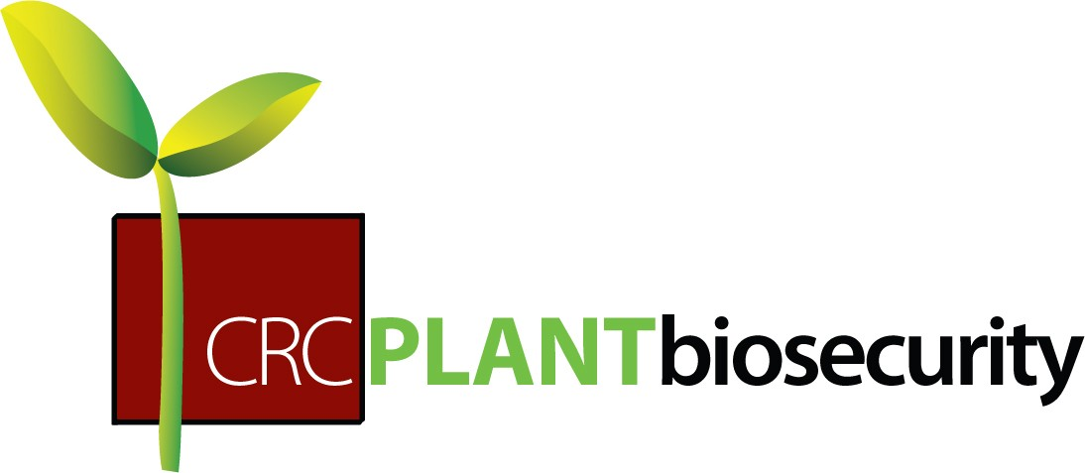
Plant Pest Investigation
Order Form
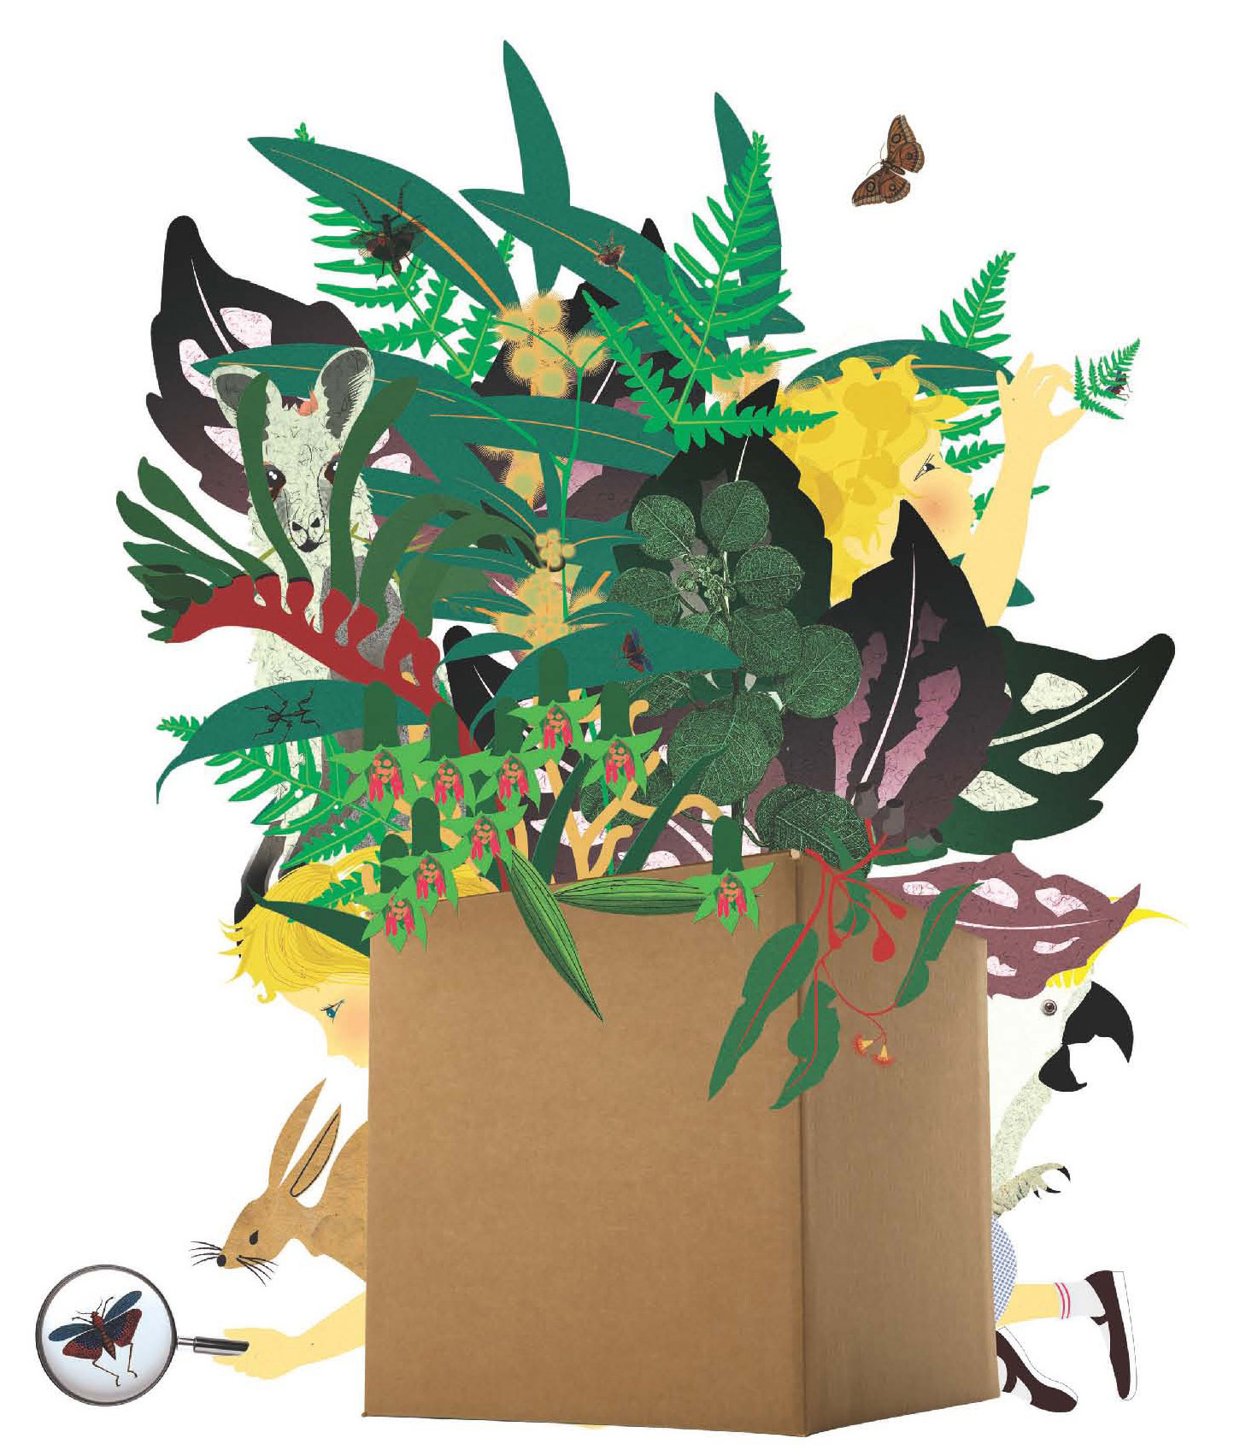
Follow Lily and Sam on a scientific investigation to find the reason behind Sam’s sick plant. Helped by Dr Wheaten, their investigation takes them through memories of their overseas holiday, a trip to their grandparents’ farm and a visit to a real science laboratory. During their investigation, they learn about the importance of protecting Australia’s crops from pests and diseases.

Plant Pest Investigation is a beautifully illustrated book written for children aged 5-8 to raise awareness of plant biosecurity issues. The big book is an educational tool with teachers’ notes and supporting classroom activities available online.

Account details:
All prices are GST inclusive. Please return this form to reserve your copy of the Plant Pest Investigation. The book/s will be sent on receipt of payment.

TITLE | ISBN | PRICE | QTY |  | TOTAL
Plant Pest Investigation | 978 1 74200 307 8 | $49.95
Postage: |  |  |  | $8.00
Total (including postage):
Name of organisation/school:
ABN: Purchase order no:(if applicable)
Attention to:
Postal address:
Suburb: State: Postcode:
Telephone:
Email:
Signature: Date:
Make payment to: CRC NPB Ltd
Bank: National Australia Bank
Account name: CRC NPB Ltd BSB: 082-926 Account number: 863 220 922
Office use only: Payment received: Date shipped: Invoice no:

Photocopy your order form and mail or fax to:
Education Officer
Cooperative Research Centre for National Plant Biosecurity
LPO Box 5012
Bruce ACT 2617
Telephone: 02 6201 2882
Fax: 02 6201 5067
email: schools@crcplantbiosecurity.com.au
web: www.crcplantbiosecurity.com.au

